# Brandon Hogue

Research Notes

Senior Design 1 – ECEN4013

Team 2 – The Omega Blade

Team role – IR transmission, receiving, protocol, and programming

9/20/15

Looked at various solutions for IR transmission and receiving.

## IR Receivers:

It seems the best way to go on the receiving side is an off-the-shelf IR module. Based on my research, the IR modules are purchased for a specific carrier frequency (e.g. 33 kHz, 56 kHz) and abstract the modulation from the microcontroller, by passing a decoded output to the microcontroller.

The considerations in choosing an IR receiver module are:

* Input voltage
* Current consumption
* Carrier frequency
* Viewing angle
* Sensitivity
* Packaging
* Spectral sensitivity at a given wavelength (940 nm ideal to match IR LED)

Based upon the design parameters and the selection criteria, my research has led me to the Vishay TSOP2xxx and TSOP4xxx line of IR receiver modules. They are available in a convenient through-hole package, and meet our requirements for 56 kHz modulated IR.

The output of the IR module is normally HIGH. If a signal is detected, the IR module will output a LOW. In terms of LED transmission testing,

* LED ON = LOW
* LED OFF = HIGH

Our carrier is 56,000 Hz, which has a period of 17.857143 microseconds. (1/56000).Based upon the requirements in the mage protocol, this implies:

|  |  |  |
| --- | --- | --- |
| Start Envelope | 10 cycle burst | 178.5 microsecond burst |
| Data Envelope | 20-70 cycle burst | 357-1250 microsecond burst |
| Stop Envelope | 150 cycle burst | 2678.5 microsecond burst |
| Max Envelope | 150 cycles | 2678.5 microseconds |

Using an interrupt service routine to check for the start packet, look for and check the two data packets, and detect the stop packet, we can decode the MIRP protocol messages.

The contents of the data packets are as follows:

|  |  |  |
| --- | --- | --- |
| Number of ON cycles | Type of packet | Description |
| 20 | Damage | Does one damage per packet |
| 30 | Healing | Heals for one health per packet |
| 40 | Stun | Stuns the device for 100ms per stun packet |

## IR Transmission:

### Emitter:

Our project requires two different IR emitters, since 3 of our blades much reach no more than 5ft, but one blade must reach 100ft. The easiest way to approach this is to select two IR emitters which are similar in design and power requirements, but differ in optical properties, specifically in angle of emission. This is formally known as Relative Radiant Intensity vs. Angular Displacement.

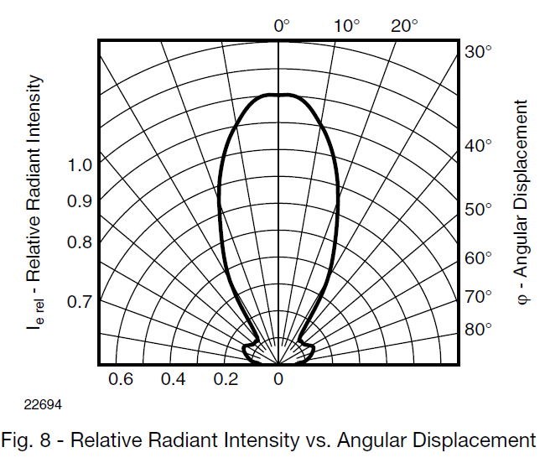

An LED with a wide angle will falloff in intensity sooner than an LED with a narrow angle, as expected. A variety of LED designs will be evaluated based on the following criteria:

* Angular Displacement (emission angle)
* Voltage and current requirement
* Intensity
* Form-factor
* Wavelength (940nm required)

At this time, a suitable LED has not been determined, although several datasheets have been selected for further review.

### Power:

The microcontroller must control the LED, and preferably provide hardware PWM at the specified 50% duty cycle at 56,000 kHz. Since the IR LED(s) will draw far too much current for a µcontroller output pin, an external method of driving the LED must be utilized.

Based upon my research, I believe an N-MOSFET will be suitable to drive the LED at the required frequency and current level.

The MOSFET must meet the following criteria:

* Must be logic level (e.g. Vgs < 3V)
* Must support rapid switching (56 kHz) – Low
* Must be capable of supplying the required forward voltage to the LED(s)
* Must be capable of supplying enough current to the LED(s)
* Must be operable at 5V (Vds)

Based upon this criteria, I have researched several suitable MOS devices, and have found the Vishay IRL110 to be suitable.

It has a logic-level gate drive, supplies up to 1.A continuous drain current at a Vgs of 5V, and has a suitable input capacitance and low Rds_on.